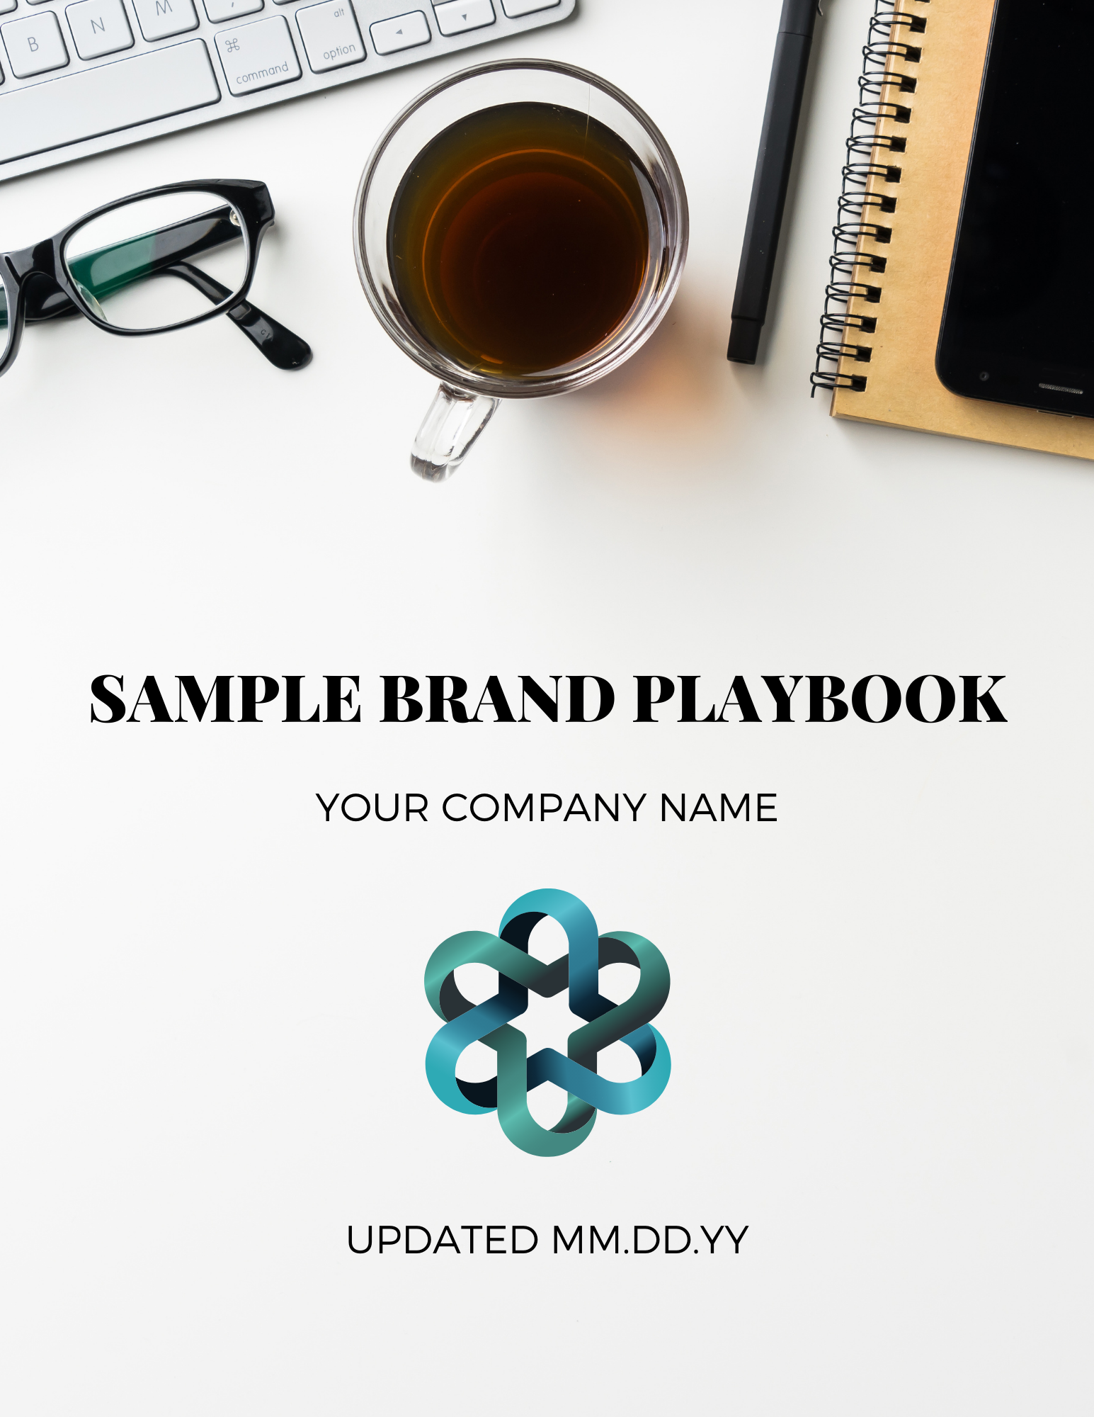

Table of Contents

1. Business Foundation 4
2. Mission, Vision, Values, Guiding Principles, and Differentiators 5
Mission Statement 5
Vision 5
Values 5
Guiding Principles 5
Differentiators 6
3. Market Positioning 7
Products and Services 7
Customer Research 8
Competitor Analysis 8
4. Growth Strategy 9
5. Client Personas 10
Fancy Florence 10
Wifey Wilma 10
Burnout Betty 10
6. Our Philosophy and Approach 12
Philosophy 12
Why We [do something others don’t, or why we don’t do this thing our competitors do] 12
7. Content Strategy + Foundation 13
Overview/Guidelines 13
Role Models 13
Brand Voice 13
8. Visual Brand Assets 15
Logo Standards 15
Fonts 15
Colors 15
9. Style Tips 16
Approved Emojis 16
Bold and Italic Type 16
Capitalization 16
Commas 16
Dates and Times 16
Hyphens, Slashes, and Ellipses 17
Numbers 17
Periods 17
Plural vs. Possessive 17
Testimonials 17
Quotations 17
URLs and Hyperlinks 18
10. Social Media Best Practices 19
General Posting Guidelines 19
Scheduling Facebook posts in Facebook Creator Studio 19
Instagram Feed 20
Instagram Stories 21
Scheduling Twitter posts in Twittimer 21

1. Business Foundation
[Include a brief synopsis of the history of YOUR COMPANY, including when it started and why it exists, etc.]

Example: YOUR COMPANY was founded in DATE YEAR by YOUR NAME, with the vision of serving YOUR AUDIENCE in the market as WHAT YOU DO.
[This part is a statement of the experience and background prior to starting YOUR COMPANY, or that led to its formation] Prior to starting YOUR COMPANY, YOU worked directly with THESE PEOPLE doing THIS. From THESE EXPERIENCES, YOU identified several gaps/challenges/ opportunities for YOUR TARGET AUDIENCE, including: [include struggles and where YOUR COMPANY is able to fill a gap in the market/provide a solution].
[In this section, you can show the options that existed prior to YOUR COMPANY’s inception.]
Example: Traditionally, YOUR CLIENTS are presented with several options:
- Explain Option 1. However, this often doesn't solve THIS PAIN POINT, because it’s challenging to find this. If you do find this, often there are other challenges that go along with it (leads to other pain points) like high cost, inefficient service, poor communication, etc.
- Explain Option 2. However, this often doesn't solve THIS PAIN POINT, because it’s challenging to find this. If you do find this, often there are other challenges that go along with it (leads to other pain points) like high cost, inefficient service, poor communication, etc.

Explain Option 3. However, this often doesn't solve THIS PAIN POINT, because it’s challenging to find this. If you do find this, often there are other challenges that go along with it (leads to other pain points) like high cost, inefficient service, poor communication, etc.

2. Mission, Vision, Values, Guiding Principles, and Differentiators

Mission Statement
[YOUR COMPANY’s mission statement will go here, and consists of three essential components: your target audience, the contribution of your product or service, and what makes the product unique or why the audience should buy it over another.]

Vision
[YOUR COMPANY’S vision statement states your current and future objectives. It’s intended as a guide to help your organization make decisions that align with its philosophy and declared set of goals. It can be thought of as a roadmap to where your company wants to be within a certain timeframe.]

Values
Values:
[These are the values that YOUR COMPANY’s products provide and that your brand represents]

Internal Culture Operation Values:
[This is your team’s culture]

Guiding Principles
- These are your core values.
- These may describe the relationship you want to have with your employees, customers, vendors, and other people you interact with.
- Example: We strive to have a solution forward approach to everything we do.
- Example: We are an inclusive environment that strives to amplify the voices of under-represented populations.
- Etc.

Differentiators
[Describe how YOUR COMPANY stands out from its competition and why your company is the clear solution to choose over others.]

Example: We believe that the services we provide should be as unique as your fingerprint. No two people are alike, so we pride ourselves on standing out from our competition by curating custom SERVICES to meet your individual needs. Our concierge, white-glove SERVICE has all of the perks at a fraction of the cost. Providing affordable luxury and a premium experience is what we pride ourselves on!

3. Market Positioning

Products and Services
YOUR COMPANY Value Proposition for Clients:
[YOUR COMPANY’s Value Proposition tells why your company is different from others, and why YOUR CLIENT should choose you as the solution to all the problems outlined in the section above.]
Example: YOUR COMPANY offers a unique approach that combines elite service with accessibility and affordability. As a result, you never have to wonder if you’ll be able to count on [speak to pain points again, reliability, affordability, communication, etc.]
When you work with YOUR COMPANY, you’ll have access to an entire team of WHAT YOU DO at your disposal, including [all the needs you meet]. This provides you with [show how the combination of services they receive offers high value]. The result is a comprehensive solution that ensures your [solution is provided].
[In this paragraph, you may want to talk about a la carte or customization options that speak to objections that prospective clients typically face and express your desire to tailor your solution to the client to earn their business.]
YOUR COMPANY’s services include: [List everything YOUR COMPANY does]
YOUR COMPANY provides companies with access to an entire team of [PEOPLE], offering a solution-based, comprehensive [WHAT YOU DO] approach.
YOUR COMPANY also partners with [PEOPLE] for specific, a la carte services such as [the custom options you offer]. This allows us to [handle certain duties, or provide expanded solutions for a range of people or problems.]
[Here you’ll want to give a high-level overview of what working with YOUR COMPANY would look like cost-wise. Describe your pricing and package structure, and what offer is best for what type of ideal client you outlined.]
Example: Because clients benefit the most by dedicating efforts that can be developed, implemented, and measured, YOUR COMPANY partners with companies on [TYPE 1] agreements so that a proper strategy can be developed and implemented all the way to completion. The average price range is [$X] for [X months] of support/service.
YOUR COMPANY differentiates itself from its competitors in the [geographic, virtual] market by providing [repeat the differentiation strategy].
[You’ll want to state some stats that show the demographic you’ve worked with and gotten results for.]

Customer Research
Please see examples of the customer persona research and analysis we conduct here.

Competitor Analysis
Please see examples of the in-depth competitor analysis we provide here.

4. Growth Strategy
This section includes what YOUR COMPANY’s approach to the market is going to be, including what their plans for growth are and how they’re going to achieve it.
It includes your plan for overcoming current and future challenges to reach your objectives for expansion. Examples of growth strategy objectives might include increasing market share and revenue, acquiring assets, or improving the organization's products or services.

5. Client Personas

[This section is a write up of the ideal client avatars or client personas we establish in the research we conduct. We name these personas for easy reference and paint a narrative picture of who they are, what their needs/pain points are, and how YOUR COMPANY can meet those needs easily.]

Example: The following are the three typical personas that are potential clients of YOUR COMPANY. Fancy Florence, Wifey Wilma, and Burnout Betty are ideal clients.

Fancy Florence
CEO
Florence is a CEO of a PR firm. She’s married with 2 teenage children, and although her husband works, she's the primary earner. She’s all business, works hard, and is well-liked and respected by her employees. Keeping a polished appearance is important to her and she likes nice things, but doesn’t want to spend too much time on it or come off showy or overdone. Efficiency is important to her and she likes to make smart financial decisions, so she wants you to get to the point clearly and quickly, because she doesn't have time to waste. If you can show her value and that you can get her the desired result while saving time and money, she’s on board.

Wifey Wilma
Housewife and Socialite
Wilma is 55 years old and is the wife of a wealthy real estate mogul. She has a glam squad come to her house to prepare her for social occasions, and employs a separate pilates instructor, dietician, chef, stylist, and massage therapist. She’s always paid the same people that are dear friends and have been on her personal care team for a long time (she says they are like family), and would love the convenience of having one person to “do it all,” but needs to make sure they are the best and can be trusted. Her husband likes the idea of saving money having one person to provide multiple self care services, but mostly just wants his wife to be entertained and happy.

Burnout Betty
Working Mom of 3
Burnout Betty is 41 years old. She’s a working mom of three school age children, and a wife to her husband of 19 years. She works a steady job in customer service that she’s not passionate about, but it pays the bills. After getting the kids fed and off to school in the morning, she rushes off to work. After a full day at the office, she comes home, cooks dinner and cleans up, and then helps with homework before getting the kids ready for school the next day. After the kids are in bed, she watches about an hour of TV before heading up to bed. Her life is happy but routine, and because she’s got a lot on her plate, it leaves little time for self care or personal development. She would love to feel better about herself, but isn’t sure it’s practical or affordable - and makes her feel a little selfish.

6. Our Philosophy and Approach

Philosophy
[In this section, you’ll want to talk about how you define your ideal clients and get them to move forward with you once you realize that working with YOUR COMPANY is a fit.]

Why We [do something others don’t, or why we don’t do this thing our competitors do]
[This section ties your philosophy back to differentiation and positioning.]
Example: Our job is to learn more about why self-care and personal development are important to our client, and understand how looking and feeling their best helps them accomplish those goals for themself with our support. This likely involves a transformation from where they are now, which may involve some inner and outer work they aren’t aware of just yet.

When we [do/don’t do this thing], it can do several things:
- The result and why we do/don’t do it
- The result and why we do/don’t do it
- The result and why we do/don’t do it
How we do it instead:
[Explain the innovation you’ve implemented, further speaking to your differentiation and USP].
Example: It is necessary to get an idea of what results they may be expecting to ensure that their goals are reasonable and achievable. When we do this, we ensure the client has the right reasons for wanting to achieve this transformation.

7. Content Strategy + Foundation

Overview/Guidelines
Things we think are RIGHT in our industry, things/approaches that we want to perpetuate:

Things we think are WRONG/not OK in our industry that we never want to perpetuate:

Role Models
Companies/ideologies that we align with, engage with, will quote or cross-share information from:

Companies/ideologies that we do NOT align with (or for some reason we simply don’t want to be associated with), do not ever quote, or cross-share information from:

Brand Voice

Commonly Used Phrases

Words/phrases that we live by in this brand (guiding principles):

Words/phrases to NEVER use

Terms That Describe Our Products and Services

- Accessible
- Luxurious
- Coveted
- Curated
- Etc.

Word Choice Preferences

- Spell out acronyms with first use, then abbreviate in subsequent uses (Impact Academy, then IA)
- Time zone (not timezone)
- Email (don’t hyphenate, don’t capitalize unless it starts the sentence)
- Login is a noun or adjective, log in is a verb
- Opt-in is a noun or adjective, opt in is a verb
- Signup is a noun or adjective, sign up is a verb
- Use positive language whenever possible (“please” or “remember to” instead of “don’t forget”)

8. Visual Brand Assets
YOUR COMPANY’s visual brand assets include its logos, fonts, and brand colors.

Logo Standards
The square logo is the default logo for use, and the [isolated element] can be used alone for branded content. The wide, horizontally-oriented logo should be used in circumstances where it fits the space better, and can be used interchangeably for visual interest.

[ADD YOUR LOGOS HERE with links to downloadable vectors]

Fonts
The brand fonts for YOUR COMPANY are Header Font (H1), Subheader Font (H2), and Body Font (body copy), with Accent Font used sparingly for flair. No other fonts should be used on any YOUR COMPANY materials unless otherwise required or approved.
The H1 and Accent Fonts should be reserved for document titles and major section headings.
[ADD YOUR FONTS HERE with links to TTF files]

Colors
YOUR COMPANY has four brand colors: COLOR 1, COLOR 2, COLOR 3, and COLOR 4. The specific color codes of these four brand colors are as follows:
[ADD YOUR COLORS AND HEX CODES HERE]

When sharing our fonts and colors with outside graphic designers or professionals, do not share the Brand Playbook but rather refer them to the YOUR COMPANY Style Guide.

9. Style Tips

Approved Emojis
- Emojis add a fun, casual touch to copy, but please use them thoughtfully!
- In social media posts, please substitute bulleted lists with emoji to highlight the start of each item in a list.
- Preferred emojis include:
⭐️ Win or shoutout
🎉 Celebration
🔥 Hot or gorgeous
💗 Love
💬 Speak up/your thoughts

Bold and Italic Type
- Bold key phrases for impact, but use sparingly.
- Use italics for verbal emphasis and program names, print magazine titles, podcasts, TV shows, and book titles.

Capitalization
- Title case capitalizes the first letter of every word except articles, prepositions, and conjunctions. Use this on webinar titles and resource titles.
- Sentence case capitalizes the first letter or the first word and proper nouns only.
- Use correct capitalization on brands and products as per their official website (iPad, YouTube)

Commas
Use the Oxford comma (a comma before the final and) when stating items in a list. (The team ate cinnamon rolls, donuts, and bagels in Wisconsin.)

Dates and Times
- Spell out the day of the week and the month (Saturday, February 26)
- Use numerals and am or pm, with no space in between, followed by a space and the time zone. (4pm ET, 3pm CT, 12pm PT)

Hyphens, Slashes, and Ellipses
- Use a hyphen without a space on either side to link words into single phrases or indicate a span (first-time buyer, Saturday-Sunday, 10am-4pm)
- Use a slash without a space on either side to indicate either or (coffee/tea)
- Use a space after three dots to indicate a casual pause (well… I’m not sure)

Numbers
- Spell out numbers less than 10 (one, two, etc.)
- Use numerals for 10 and over (10 website clients and 30 accounts total)
- Use commas in numbers with more than three digits (1,000 and 300,000)
- Abbreviate numbers with uppercase K ($275K)

Periods
One space after a period.

Plural vs. Possessive
Multiples do not use an apostrophe, even if they are initials (three URLs, not three URL’s) unless it belongs to the URL (the URL’s name).

Testimonials
As a best practice, bold the best part of the testimonial and copy it over at the top of the client quote. Skip a line and give the full quote in italics, bolding the phrase that you pulled to the top to show it in context and highlight it. The client’s name and title go below their quote.

Quotations
Punctuation goes inside quotation marks. (Amber said, “I ate a cinnamon roll.”)

URLs and Hyperlinks
- Do not use www or http:// (strategiesthatpay.com)
- Use all lowercase letters.
- Include the punctuation if the whole sentence is hyperlinked.
- Don’t hyperlink parentheses (Click here to register.)

10. Social Media Best Practices

General Posting Guidelines
Follow these guidelines when creating or formatting content for social media accounts across all platforms. Each piece of content should be formatted specifically for each platform according to its capabilities and character limits.

- Always use a critical eye and re-read posts after copying and pasting content.
- Preview everything and make sure it looks normal.
- Make sure tags are appropriate for the platform (IG is @, FB should highlight person).
- Use emojis, but sparingly.
Resources:
- Facebook Logins
- Instagram Logins
- Twitter Logins
- Canva Logins
- Airtable
- Sprout Social character counter
- Sprout Social image size guide

Information Needed Before Starting:
- Post copy and cropped images must be approved prior to scheduling or posting.
- Get the IG handle or FB profile of anyone that will be tagged in the post prior to posting.

Scheduling Facebook posts in Facebook Creator Studio
Image: Horizontal or square images work best, ideal dimensions: 800px x 800px

Character limit: 63,206

- Login to Facebook account.
- Click “Publishing Tools.”
- On the left hand menu, click “Creator Studio.”
- Click the Facebook icon on the top menu bar.
- Click “Post something.”
- In the box, paste your approved copy.
  - Use emojis in place of bullet points.
  - Use number emojis in place of numbered lists or numbers.
  - Use Facebook tags by beginning to type @ and the person’s name and choose from the list that pops up.
- Proofread.
- Upload the appropriately sized media or image by clicking the button below the post copy.
- Once the post looks good, click the dropdown arrow to the right of the blue “Publish” button on the bottom right corner.
- Click the checkmark next to “Schedule” and select the correct date and publishing time.
- Click “Schedule” again.
- To make edits or reschedule, you can see your post in the Content Library.

Instagram Feed
Image: Horizontal or square images work best, square shows in newsfeed, ideal dimensions: 1080px x 1080px

Character limit: 2,200 including spaces

Hashtag limit: 30

- Adding line breaks to your Instagram post:
  - Copy and paste the approved copy into the Instagram Line Breaker Tool.
  - Delete any extra line breaks and add any IG handles present in the post copy.
  - Proofread.
  - Ensure the character count is under 2200.
  - Click the “Copy to Clipboard” button in the top right corner to convert the post copy and automatically add the extra characters for line breaks.
  - Login to Facebook account to schedule the Instagram post.

- Scheduling Instagram posts in Facebook Creator Studio:
  - Click “Publishing Tools.”
  - On the left hand menu, click “Creator Studio.”
  - Click the Instagram icon on the top menu bar.
  - Click the blue “Create Post” button in the left hand menu, and use the dropdown to select “Instagram Feed.”
  - Confirm you’re posting in the correct account by checking the profile picture that appears.
  - In the “Your Post” box, paste what you copied from Instagram Line Breaker in Step 1.e.
  - Click the plus sign in the gray “Add Content” section and upload the appropriately sized image.
    - If it’s a carousel post, upload multiple images by holding the command button while you select the files.
    - Ensure the files appear in the correct order by adding ordinal numbers under each upload.
  - If needed, you can tag someone in the photo by clicking the “Tag Media” icon under the upload.
  - Once the post looks good, click the dropdown arrow to the right of the blue “Publish” button on the bottom right corner.
  - Click the checkmark next to “Schedule” and select the correct date and publishing time.
  - Click “Schedule” again.
  - To make edits or reschedule, you can see your post in the Content Library.

Instagram Stories
Image: Vertical works best, ideal dimensions: 1080px x 1920px

- Upload the appropriately sized image by clicking “Upload Media” on the top left.
  - Upload anything with moving elements as an MP4 file.
  - Upload multiple images by holding the command button while you select the files.
- Click “Stories” in the menu near the top right.
- Hold command to select multiple files and drag them from the left hand grid into the correct time and date in the timeline.
- Drag to reorder uploaded panels as needed.
- Add the swipe up URL to the “Add Clipboard Text” section.
- Once the post looks good, ensure the correct date and publishing time are selected.
- Click “Save Story.”

Scheduling Twitter posts in Twittimer
Image: Horizontal works best, ideal dimensions: 600px x 335px

Character limit: 280

- Log in to Twittimer.com.
- Click “New Message.”
- In the box, paste your approved copy.
  - Use Twitter tags by typing @ and the person’s handle.
  - Convert any links at Tinyurl.com.
- Proofread.
- Click the camera icon on the bottom left of the gray box to upload the appropriately sized image.
- Click the correct picture to select the linked Twitter account.
- Select the correct date and publishing time.
- Click “Schedule.”

All Intellectual Property (“IP”) created by Strategic Partners Marketing LLC and the Impact Academy team, Coach and/or Team of Experts is for Client’s individual use only to apply the learnings in the client’s business. All IP shall remain the sole property of Strategic Partners Marketing LLC and Client agrees to not reproduce, duplicate, copy, share, sell, distribute, trade, or otherwise disseminate or exploit for any commercial purposes any portion of the IP provided in connection therewith. Strategic Partners Marketing LLC does not make any representation or warranties as to the accuracy, applicability, or completeness of materials. The coach shall not, under any circumstances, be held liable for any loss or other damages of any kind by use of these materials. As always, please seek the advice of a competent legal, tax, accounting, or other professional when needed. All links are for informational purposes and are not warranted for content, accuracy, or any other implied or explicit purpose. This manual contains material protected under International and Federal Copyright Laws and Treaties.

