YOUR NAME BRAND PLAYBOOK

1. Visual Brand Assets
Your name’s visual brand assets include its logo, its fonts, and its brand colors.

Logo Standards
Below is the primary logo for Your Business Name. Black, white, or gray-scale versions of the logos shall only be used if requested by a third party or if the background is such a color that the primary logo is not sufficiently prominent.


Fonts
The Your Business Name fonts are Oswald (headers) and Open Sans (body copy). No other fonts should be used on any Your Business Name materials unless otherwise required or approved.
For H1 headings or additional emphasis, Oswald may be bold, semibold, or medium, if desired. In general, all H2 headings shall be lowercase, unless otherwise noted; H1 headings may be in all caps.

H1: Your Business Name
H2: Your dependable Dane County plumbing team
Body: Let us help you remodel your bathroom with a custom shower and new sink.
(Oswald Medium, 20pt; Oswald, 14pt; Open Sans, 11pt)

Colors
Your Business Name has three primary brand colors: Mexico Blue, Light Blue, and Steel Blue (see left-hand column below). Kelly Green, dark gray, black, and white may be used as accents.

HEX: #1E66B0
RGB: 30,102,176
CMYK: 83,42,0,31
PANTONE: 647 C

HEX: #2AA83C
RGB: 42,168,60
CMYK: 75,0,64,34
PANTONE: 7739 C

HEX: #5EA8EE
RGB: 94,168,238
CMYK: 61,29,0,7
PANTONE: 284 C

HEX: #47484C
RGB: 71,72,76
CMYK: 7,5,0,70
PANTONE: 7540 C

HEX: #9AA6B7
RGB: 154,166,183
CMYK: 16,9,0,28
PANTONE: 5543C

For dark text, black, dark gray, and Mexico Blue shall be allowable; for light text, white or light blue shall be used.

Stock Photos
Natural, contemporary-looking stock photos that showcase bathrooms, kitchens, and plumbing equipment (e.g., hot water heaters) are allowable. Stock images with people are not preferred.
The filter/color of the photo will be gray or blue to have a cool tone and better match the Your Business Name brand colors. The colors will be crisp and clean so that the photo is engaging and vibrant without being overly harsh or showy. Ideally, photos will be landscape unless they are company headshots; however, any photo may be cropped so that it better fits a square or portrait frame.
Examples of possible stock photos have been included below.
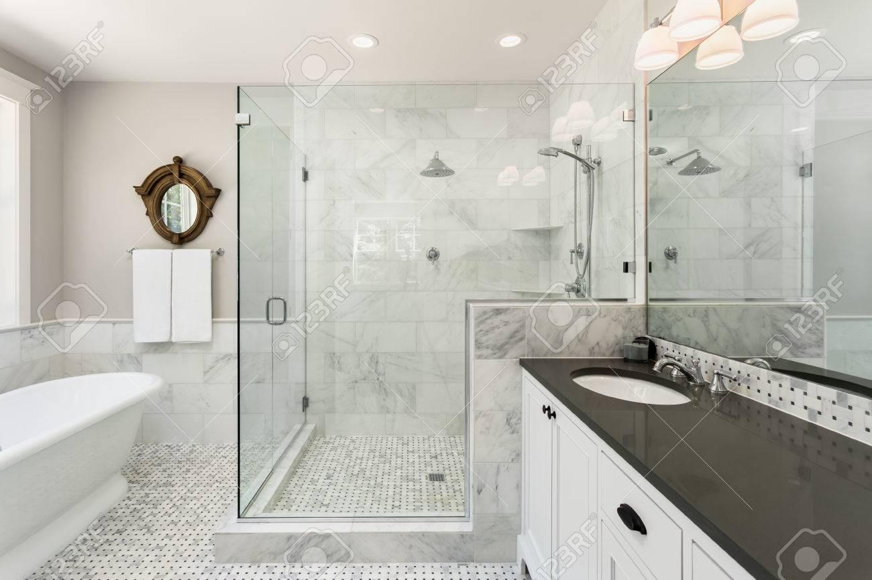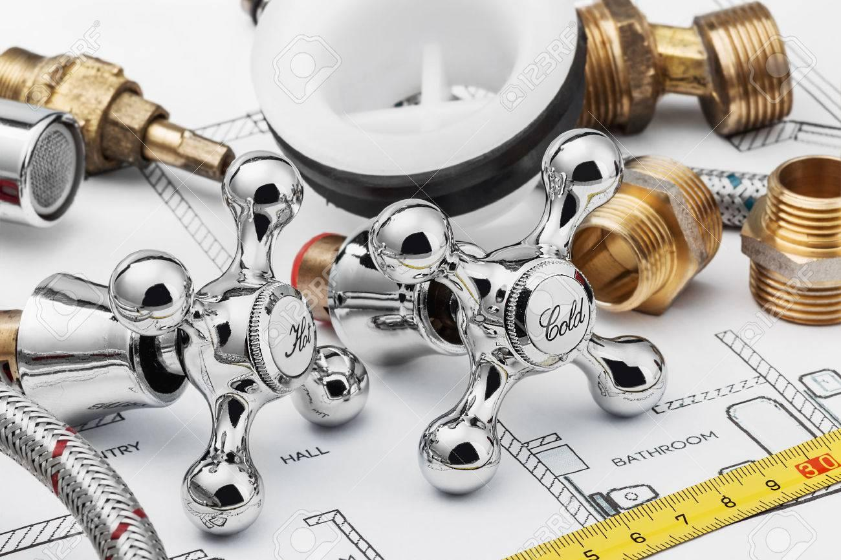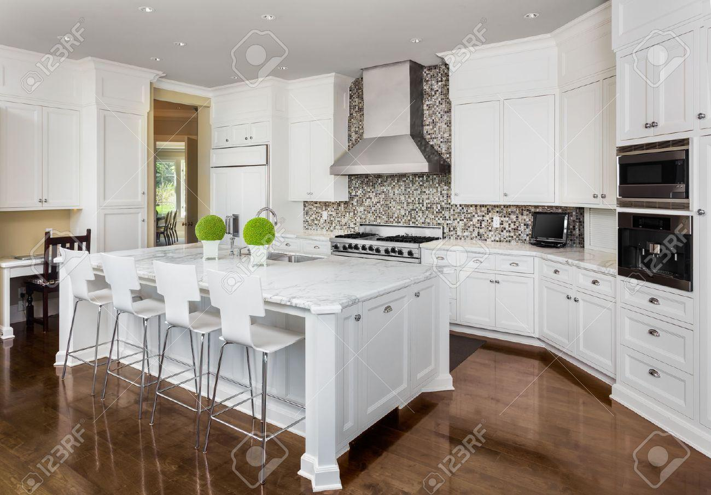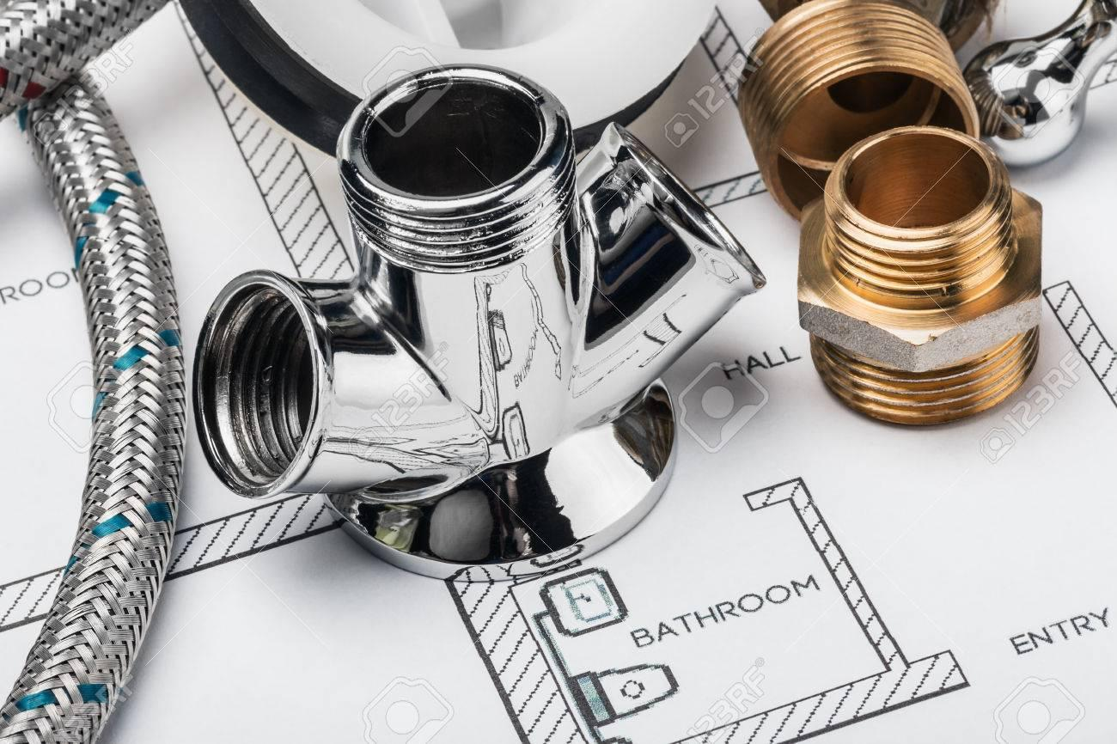

2. Brand Foundation

Guiding Principles, Mission, Vision, Values
Your Business Name strives to be a customer-centric organization whose brand and company tone are friendly, professionable, approachable, and transparent.

Guiding Principles
The guiding principles are the fundamental beliefs that steer your organization.

Examples of Strategic Partner’s Guiding Principles:
- The value is in partnership
- Businesses exist for a purpose beyond just making money
- Empowered leaders create greater impact
- Effective business building is rooted in both passion and strategy
- No business leader with their heart in the right place, should fail due to lack of resources
Mission Statement
The mission statement says why your company exists. The mission is what you fulfill over and over again.
There are 4 main components to the mission statement:
What do we do?
How do we do it?
Whom do we do it for?
What value are we bringing to our prospective clients/why does it matter to clients?

Example of SP mission statement:
“Empower values-driven people and companies to become their best, by providing business, marketing, and personal development support, rooted in passion and empowered by strategy.”

Breaking it down:
What: Empower to become their best
How: by providing business, marketing, and personal development support
Whom do we do it for? Values-driven people and companies
What value are we bringing to our prospective clients/why does it matter to clients?: Rooted in passion and empowered by strategy.

Vision
The vision is the future desired position of the company.

Example:
“To establish Strategic Partners as the go-to-partner for values-driven people and companies who are passionate about becoming their best, while keeping our growth rooted in authentic passion and intentional strategy."

Values
Your Business Name has the following values, which affect its clients, employees, and approach to service. These are just some of the ways these values are exemplified:

Transparency. We want every step of the process to be straightforward and easily understandable for the client.
Expertise. We offer insight and advice tailored towards your project based on our many decades of combined experience.
Craftsmanship. We only use products that we can guarantee, and we strive to get the work done right the first time.
Friendliness. Our customers invite us into their homes, so it’s imperative that they are comfortable with our personnel, and trust that we will take care of their needs in an approachable, open manner.

3. Market Positioning

Competitive Analysis Summary
Link to the competitor excel sheet you have filled out.
Over the course of this project, we analyzed five different competitors to review Your Business Name place in the market. These competitors included:

- Competitor 1
- 2
- 3
- 4
- 5

Of these five competitors, the most directly relevant is XYZ. They have a consistently branded website, focus on residential remodeling services, and their website copy clearly communicates how they value craftsmanship and transparency.

Most competitive plumbers also do service work and are available 24/7. For sales inquiries into remodeling projects, 40% of the competitors responded to a sales inquiry by phone within 30 minutes.
The larger scope of services, particularly emergency plumbing services, allow them to get in front of more customers, but also requires significantly more man-hours to manage and execute.

We summarized the key points of these five competitors below; please see the “Competitor Analysis + Customer Personas” document for a more thorough review.

Customer Interviews
The customer survey was emailed to 25 customers and the Facebook page, we compiled the 16 respondents (4 from Facebook, 12 from email) in a pivot table here - hyperlink here to any customer interview data you have documented

We requested phone interviews from 6 recent customers. Three agreed, and their interviews are individually linked below:

Interview Links - hyperlink here

Interview Findings
- This is where you include quotes from the interviews and summarize the findings

Marketing

When it comes to social media, Your Business Name has a Facebook page with above average amounts of genuine engagement from friends and customers. Most competitors have outdated or rarely used Facebook pages, and no other social media avenues are actively used. (Facebook continues to drive ~20% of Your Business Name web traffic per month).

About half use regular thought leadership / blogs to establish themselves as experts. Most competitors have double or triple the website traffic than Your Business Name, even the smaller businesses. A significant percentage is paid traffic. There are many factors contributing to this gap, but time is likely the greatest factor.

Regarding other marketing channels, SEO directories such as Yelp, Houzz and Angieslist are areas of strength for the competitors - especially due to dozens, if not hundreds, of positive reviews over the years. Many invest in paid services in order to update dozens of directories quickly and manage leads instead of manually requesting changes.

Well-established, medium and small sized businesses such as Benjamin form partnerships with general contractors through strategic networking at membership organizations such as NARI, MABA, and the Madison Chamber of Commerce. Medium to larger competitors such as Mad City will expo at the trade shows for these associations.

Larger competitors, such as Action and Mad City, invest in massive ($xxx,xxx) paid media campaigns. While this isn’t recommended for a smaller company with limited availability, the brand recognition these campaigns create does give them a competitive edge.

In comparison to the competitors, Your Business Name project portfolio is subpar. The photos are of low quality, sometimes blurry, so they don’t look as professional. They also aren’t as prominently displayed or easy to find - no dedicated portfolio page like most competitors.

Niche
With regard to niche, Your Business Name is well-positioned to specialize in bathroom remodeling and general contracting.

SWOT Analysis
Strengths: small team, quality control, great reputation, responsiveness, sales acumen - high conversion rate

Weaknesses: new (few reviews, small portfolio), few strategic partnerships, narrow scope of service offerings limits how many new leads you can interact with, team members seem to lack an eye for detail

Opportunities: K’s pricing is competitive, GC-ing bathrooms, bandwidth to add on larger projects (more kitchens, Aging in Place demographic)

Threats: limited availability, dependent on a strong housing market / economy in general, potential loss of quality as Owner stops plumbing, competitors with larger digital and media budgets reach more leads, difficulties staffing high quality plumbers

Customer Personas
Examining existing customers, potential opportunities, and the most enjoyable engagements, we determined that developing personas for general contractors, young couples with fixer uppers, soon-to-be retiring Baby Boomers, and potentially, property managers were the most lucrative.

Gene the General Contractor
Demographics | Business Size: Medium (10 - 25) Annual Revenue: $1M - $5M Household Income: $100,000 - $200,000 Education: One or more trades, Certified General Contractor Age: 35 - 55 Location: Madison Area Gender: 5% Female, 95% Male
Persona Background | Gene is married with four children, in his 40's. He's worked as a general contractor for almost 20 years, and owned his own business for 10. He checks his email first thing in the morning around 6am, but will put his phone away after 6pm to focus on his family. He's very protective of his company's reputation and values high quality work. He knows that some general contractors only care about the bottom line, and don't have their customers’ best interests at heart. He strives to be the best general contractor in town. If he had it his way, he wouldn't have to rely on any subcontractors.
Client Examples | Actuate
Identifiers | Gene has a low tolerance for error or lack of availability. He plays things very close to the chest, so he doesn't overshare information about customers, budgets, etc. Asks for a lot of information from you up front. Found you through a word-of-mouth referral.
Persona Goals | Take on as much business as possible. Find subcontractors who share his values of craftsmanship.
Pain Points | Subcontractors have let them down in the past. He needs someone that will deliver on what they're contracted to do, someone to rely on who won't give him the runaround. He's turning away business because they can't keep up with demand. He needs someone that will be responsive; he wants to find someone who aligns with his values.
Information Research Process | Referrals, relationships built on trust, systems in place to do official background checks
Questions They’ll Ask | Who do you know? - spend more time talking about who you've worked with. How long have you been around? What are your rates? Do you have a criminal record - (he won't ask, but he'll happily pay for a background check. save him the time.) (Do you have an info packet that you send out to GCs with all this?). What are your vendors?
Perceived Barriers | lack of availability, not aware of who he is or who he's worked with, trust issues (been burned), concern Owner can't scale/handle a large project (level of experience/size of business).
Final Thoughts Before They Buy | "I need help, I'm kind of desperate, but I've been burned before. This guy checks out, he seems like he has a good head on his shoulders, and he's been responsive."
How Quickly They’ll Adopt (1-10) | In general, quickly: 7.5-8. A spectrum depending on where THEY are at in their contract process, but just as many who will take their time for projects that are a few months out. In general, quickly
Real Client Quotes | “I look for ones that are able to respond. I’ve been in the industry 20 years, so I know what to look for. Who’s least likely to let us down? I have a background check process, I get references, and I ask the other builders / contractors that I know. Someone had recommended him at the beginning.”
Suggested Marketing Strategies | Strategic networking through membership organizations: NARI, MABA. Marketing collateral that can easily be shared with GCs and provides them with all the info they need to know KP is the sub for them.  Website section optimized for GCs - give them all the info they need, quickly and easily. Marketing collateral available for download/view directly from website.
Your Marketing Message | Been burned by a subcontractor that didn't follow through, or did meet your high quality standards? Your Business Name Plumbing takes subcontractor work extremely seriously, and has the experience and references to back it up. We pride ourselves on being responsive partners for your bathroom and kitchen plumbing needs. When you're ready to bring on a sub that will be a long-term partner to help you get more jobs done right, contact Owner at Your Business Name.  You want a subcontractor who is easily reachable and who will do what he's promised he will do. We believe in high quality work that gets done right the first time. View our licenses, background checks, credit report and recent projects here. You can find a list of general contractors who have hired us and their contact info here.

Kelly and Kyle, The Fixer Uppers
Demographics | Combined Household Income: $80,000 - $175,000 Education: Bachelor's Degree, some Graduate school Age: 28-50 Location: Madison Gender: 60% Female, 40% Male
Persona Background | Kelly and Kyle are a young couple living in Dane County. They used to live in downtown Madison, but as they have settled, their need for more space required a move into the surrounding communities. They are in their mid-to-late 30s, and just had their first child. They recently moved into the second home and learned a ton about how to be smart home owners with their first home. This time around, Kelly and Kyle understand the value of updated bathrooms and kitchens, and know that if they ever want to sell this home, they will need to do some updates. Between their jobs as accountants, and their one-year old, their lives are pretty chaotic. They made some money on the sale of their first house, so they are excited about being able to invest in their new home relatively quickly.
Client Examples
Identifiers | They'll have already done their research about you / read your website before reaching out, as they are pretty savvy with social media. Often, they first hire you for something smaller like a water heater replacement, then reach out for a larger project once they trust you. They'll be shy about asking questions at first because they don't want to appear inexperienced. They really dislike a "hard sell" and will look for someone that's transparent. They are a little gun shy, as this is relatively new territory for them.
Persona Goals | They want their dream home - and know they can't afford it today, so they're making upgrades as they can afford them. They want a reliable, trusted plumber that they can turn to - the first job isn't the big $$, it's their lifetime value as a customer.
Pain Points | They want education / tips without appearing like they're clueless. They don't want to get taken advantage of or screwed over. They aren't sure which questions to ask, and they hate feeling dragged through a process they don't understand. They want more than just a plumber that will run the lines and leave, they want someone who will offer insight and really take their needs to heart.
Information Research Process | They'll look at digital footprint - online reviews, website presence, an active Facebook. They'll ask friends who also own houses for referrals.
Questions They’ll Ask | How long will this process take you? Are there any other costs we should anticipate? Is there a warranty on the work in case something goes wrong?
Perceived Barriers | They're worried they'll make the 'wrong' choice and trust someone untrustworthy. They are unsure of the process, and wonder if this will be too big of an undertaking. How involved will they have to be?
Final Thoughts Before They Buy | I hope this goes as planned. I hope this doesn't cost me any more money. Is this company going to do a good job? We really don't want to have to do this again in this house, so this better last.
How Quickly They’ll Adopt (1-10) | 5, they don't have a deadline or pressing needs for this remodel. They'll gather a few other quotes before deciding.
Real Client Quotes | “I thought he would have more input/ideas to give. I wanted his input, but he just agreed to our suggestions / ideas” ; “Yep, we can make that work.”
Suggested Marketing Strategies | Google Ads to drive online inquiries  Social Media Marketing to warm up consumers to brand  Regular blog posts that educate
Your Marketing Message | Work with a kitchen and bathroom remodeling expert you can trust. Our professionals will provide you with the best recommendations for your unique situation and wishlist, and offer design recommendations to bring your outdated spaces into the present. With full transparency and clear quotes, you'll know exactly what you're getting, with no surprises. Trust the experience and integrity of Your Business Name on your next kitchen or bathroom remodel.

Joe and Joannie - Aging In Place Boomer Couple
Demographics | Combined Household Income: $80,000 - $300,000 (but less debt, likely own home outright) Education: Bachelor's Degree Age: 50-65 Location: Madison Gender: 60% Female, 40% Male
Persona Background | Joe and Joannie have been in their home for 30 years, and despite their best efforts to find a place to ultimately retire in, have not been able to find a house that checks all the boxes. So, they have decided to invest in their current home, and make it the place they will be able to retire. That means making some changes to the layout of the home to accommodate Joe's bad knees, and Joannie's back issues. Joe is planning on retiring in the next 5 years, and Joannie recently decided to retire early. This means that there is more time to focus on their home than there has been in the past, so they know what they want. Joe and Joannie have been through remodels in the past, and know what kind of contractor they want to work with. Because this will likely be the last round of renovations they will ever do in this home, they are willing to spend some money to get it just the way they want it.
Client Examples | N/A
Identifiers | They're used to trusting big, well-established brands (despite quality), and they like buying things that they're familiar with. They aren't usually very tech-savvy, so they'll ask a lot of questions that could be answered by reading your website. Joe and Joannie are relatively familiar with the costs and time period involved in these types of renovations. They may resist some aging in place modifications - i.e. Joe doesn't think they need a toilet with handlebars yet, because he isn't "that old yet," but his wife is more of a practical planner.
Persona Goals | Comfort in their forever home. They want it done right the first time.
Pain Points | Their income is only dynamic for a few more years, so they want to get a good deal before they transition to a fixed income (retirement) lifestyle. They have been through remodels in the past, and have gone the cheap route before, and been burned. They are looking for someone they can trust and will get the job done right, at the right price. They are not interested in cutting corners. They want it done exactly they way they want it. Few compromises.
Information Research Process | They'll want to see recent work, and know what your reputation is in the area. They will also want to meet in person to make sure they feel comfortable with you in their home. Not afraid of phone calls, and don't take kindly to an unresponsive contractor.
Questions They’ll Ask | How long have you been in business? Can you show me some examples of work you've done? How did you come to this number / quote?
Perceived Barriers | This plumber doesn't have the experience or portfolio for us to trust him. Is this going to end up like we wanted, or will there be compromises we have to make? Is this going to take forever, or will this guy get it done on time?
Final Thoughts Before They Buy | This guy checks out. He was personable in person, has done the kinds of things we want him to do, and has done work in the area before. I think we can trust him.
How Quickly They’ll Adopt (1-10) | 3 - They will do their homework, and get multiple bids before moving forward. They aren't in a huge hurry, as their updates are for the long term.
Real Client Quotes
Suggested Marketing Strategies | Schedule on-site meetings to discuss plans, have ipad or other portable device available to showcase examples.  Google ads to drive calls in addition to online form submissions  Regularly update website galleries with projects  Incorporate geography into website gallery, such as a map with recent projects marked  Have a list of references readily available
Your Marketing Message | Your Business Name is your trusted partner for kitchen and bathroom updates that will make you fall in love with your forever home all over again. With 40+ years of experience in the Madison area, you can count on the friendly professionals at Your Business Name to get the job done right at the right price.

4. Brand Messaging
Core brand messaging includes its tagline, elevator pitch, and key messaging statements. This messaging was derived, in part, from what our team learned about Your Business Name from market research, competitor analysis, customer interviews and from what you shared about why your business exists.

Elevator Speech
Your Business Name is a home remodeling and plumbing company specializing in kitchen and bathroom renovations. Our core values of transparency, expertise, craftsmanship, and friendliness ensure that every client is treated with respect, and every project is completed on-time, on-budget, and without surprises.

Messaging Statements
- Your Business Name sets a new quality standard by only using products we can guarantee.
- Been burned by a subcontractor that didn't follow through, or didn’t meet your high quality standards? Your Business Name Plumbing takes subcontractor work extremely seriously, and has the experience and references to back it up. We pride ourselves on being responsive partners for your bathroom and kitchen plumbing needs. When you're ready to bring on a sub that will be a long-term partner to help you get more jobs done right, contact Owner at Your Business Name.
- You want a subcontractor that is easily reachable and who will do what he's promised he will do. We believe in high quality work that gets done right the first time. View our licenses, background checks, and credit report and recent projects here. You can find a list of general contractors who have hired us and their contact info here.
- Work with a kitchen and bathroom remodeling expert you can trust with Your Business Name. Our professionals will provide you with the best recommendations for your unique situation and wishlist, and offer design recommendations to bring your outdated spaces into the present. With full transparency and clear quotes, you'll know exactly what you're getting, with no surprises. Trust the experience and integrity of Your Business Name on your next kitchen or bathroom remodel.
- Your Business Name is your trusted partner for kitchen and bathroom updates that will make you fall in love with your forever home all over again. With 40+ years of experience in the Madison area, you can count on the friendly professionals at Your Business Name to get the job done right at the right price.

Suggested Tagline
Your Business Name. Your Neighborhood Plumbing and Remodeling Specialists.

5. Growth Strategy
Now that you have clarity for what your brand is, your place in the market, who you are communicating with and how, what have you defined as your path to growth? Are you wanting to sell more to less people? Sell more to more people? A combination?

Document your growth strategy in the Strategic Planning Framework and hyperlink that guide here.

Channels for growth:
- Market penetration with new customer acquisition - selling more to new customers within the current market you are in
- Market Penetration with existing customers: Sell higher dollar or more products and services to existing customers.
- Product Expansion/Development - continue selling new/expanded products within the existing market
- Market expansion - expanding into a new market either a new target audience or new areas geographically, into new areas where your prospective customers are
- Diversification - selling new products to new markets
- Acquisition of other companies - acquiring other companies to expand your operations

